**Burton Road to West Bay Trailway**

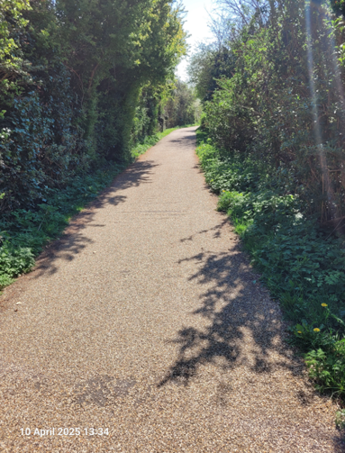 **A New Management Plan 2025-2030**

**Why a new plan?**

The trailway runs along the north side of Burton Road from Chestnut Road to Marsh Gate, crossing the road taking in the green, it then runs down to West Bay ending at the public toilets in West Bay Road car park. The trailway is enjoyed by walkers, dog walkers, mobility aid users, as well as cyclists and horse riders. The trailway was transferred to Bridport Town Council by West Dorset District Council in June 2021, and following the transition to a unitary authority, responsibility for the trailway surface now lies with Dorset Council.

The management plan for the trailway will ensure that the interests of wildlife and users are balanced, and mitigations are put in place to address community concerns.

**How will the new management plan be developed?**

It is important that the future management of the trailway respects the interests of local residents, wildlife and those who currently enjoy the space. There are aspects of the site which need to be maintained including the ditch north of Meadowlands, verges, hedges, grass cutting, trees, play and picnic areas.

A consultation phase is essential to gathering information about what currently works well and what ideas for improvements should be considered in developing a management plan for the next five years. Over the next few months the Town Council will be working with local residents and the wider community to do this.

|  |  |  |
| --- | --- | --- |
| **What** | **When** | **How** |
| Collecting information about current uses and ideas on the draft management plan | June to August 2025 | Postcard/website, emails and community events  An open site meeting (details to come) |
| A draft plan for community consultation | September to October 2025 | Document available online and on local display |
| Final plan adopted by Town Council | November 2025 | Document and summary published online |

Send your thoughts on the management plan to [enquiries@bridport-tc.gov.uk](mailto:enquiries@bridport-tc.gov.uk) or return this postcard to Bridport Town Council, Mountfield, Rax Lane, Bridport, DT6 3JP **by 31st August 2025.**

The draft management plan can be found [www.bridport-tc.gov.uk/burton-road-to-west-bay-trailway](http://www.bridport-tc.gov.uk/burton-road-to-west-bay-trailway)

|  |  |
| --- | --- |
| **What I like best about the trailway is…** | **The trailway could be improved as an amenity space by…** |
| **Do you agree the trailway should be registered as an open space in the Bridport Area Neighbourhood Plan?** | **Do you think Bridport Town Council maintains the trailway adequately?** |
| **Would you like to express an interest in joining a volunteer group to help run the trailway with Bridport Town Council?** If yes, please include your name, phone number and email address. | **What would you consider to be the main priority for the trailway in the next 5 years?** |
| **How do you think maintenance work should be funded (please tick):**  **Sale of land/licence of land Increase in council tax**  **Reduction of other council services**  **Through voluntary groups**  **Other (please state) ………………………………………………………………………**  **……………………………………………………………………………………………..………** | **Other thoughts?** |