Green Lane and Slades Green, Bothenhampton
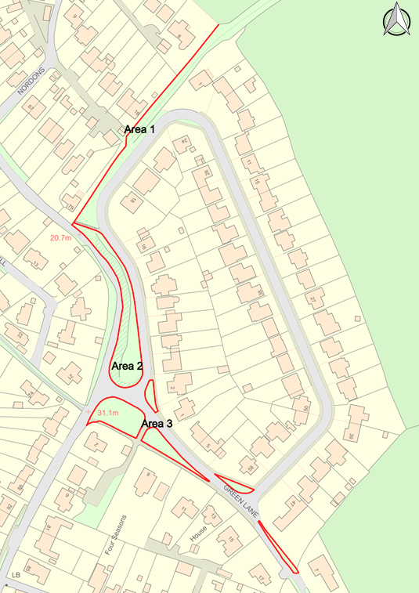
Management Plan 2026-2031

The land begins from the junction of Crock Lane leading onto Green Lane and Slades Green, Bothenhampton. The area is made up of several grassed verges some of which are on a sloping bank or tree lined. The area also includes a Right of Way which is accessible from Crock Lane.

Following the declaration of a Climate Emergency all management plans for Bridport Town Council’s green spaces are being reviewed. This area has not previously had a management plan. The review considers current uses and looks to improve the area for wildlife, and community use.

How will the new management plan be developed?

It is important that the future management of the area respects the interests of local residents, wildlife and those who currently enjoy the space.

A consultation phase is essential to gathering information about what currently works well and what ideas for improvements should be considered in developing a management plan for the next five years. Over the next few months Bridport Town Council will be working with local residents and the wider community to do this.

The draft management plan can be found at: https://www.bridport-tc.gov.uk/

What | When | How
Collecting information about current uses and ideas on the draft management plan | June to August 2026 | Postcard/website, emails and community events
Final plan adopted by Town Council | September 2026 | Document finalised and published

What I like best about the area is………. | The area could be improved by……
How would you like area 1 to be managed? | How would you like area 2 to be managed?
How would you like area 3 to be managed? | What would you consider to be the main priority for the next 5 years?
Would you like to express an interest in joining a volunteer group? If yes, please include your name, phone number and email address. | Other thoughts?

Send your thoughts on the management plan to enquiries@bridport-tc.gov.uk or return this postcard to Bridport Town Council, Mountfield, Rax Lane, Bridport, DT6 3JP by the 30th August 2026

